VOLUSIA COUNTY SHERIFF’S OFFICE MEDIA RELEASE
Dec. 7, 2020
For immediate release
Contact: Andrew Gant, Office of Public Affairs & Media Relations
DELAND MAN CHARGED WITH ANIMAL CRUELTY,
CHILD ABUSE IN KILLING OF 2 DOGS
A DeLand man is facing charges including felony animal cruelty and child abuse after he shot and killed two of his fiancée’s dogs and tried to make a 16-year-old boy shoot one of them.
William Petty, 49 (DOB 6/16/1971), of DeLand, was arrested Sunday afternoon in Port Orange, a day after the Saturday incident in the Daytona Park Estates area of DeLand.

Deputies responded around noon Saturday after the 16-year-old told his mother what happened. He said he was at Petty’s home in DeLand over the weekend, and after Petty got into an argument with his fiancée, Petty loaded up two of her dogs (a female Catahoula mix and a male Dachshund) and drove them to a wooded area off the 1400 block of 12th Avenue, DeLand.

There, Petty pulled out a revolver and shot the female Catahoula mix in the head. Petty then handed the gun to the 16-year-old, telling him to do the same to the second dog. The 16-year-old shot at the ground instead. Petty took back the gun and shot the Dachshund in the head, then tossed both dogs into the woods.

Deputies retrieved the dogs and consulted with Volusia County Animal Services officers, who took custody of both deceased animals.

The dogs’ owner confirmed neither dog had any illnesses or ailments that would have called for them to be euthanized.

Petty was not immediately located, but a warrant was issued for his arrest before he was located in Port Orange on Sunday.

He was charged with two counts of felony cruelty to animals, two counts of unlawful disposal of a dead domestic animal, child abuse and carrying a concealed weapon in the commission of a felony. He was still in custody without bond Monday morning at the Volusia County Branch Jail.

Please report animal cruelty to the Sheriff’s Office at 386-248-1777 or 911 in an emergency, or contact Volusia County Animal Services directly at 386-248-1790.
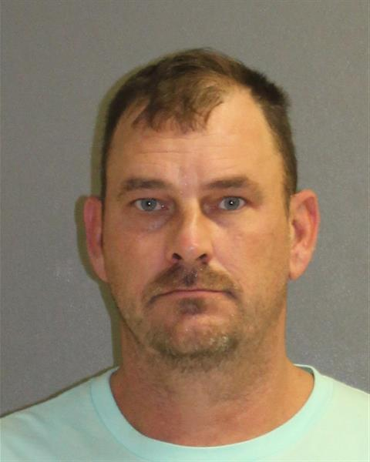

William Petty

